1st semester: SGPA 9.90

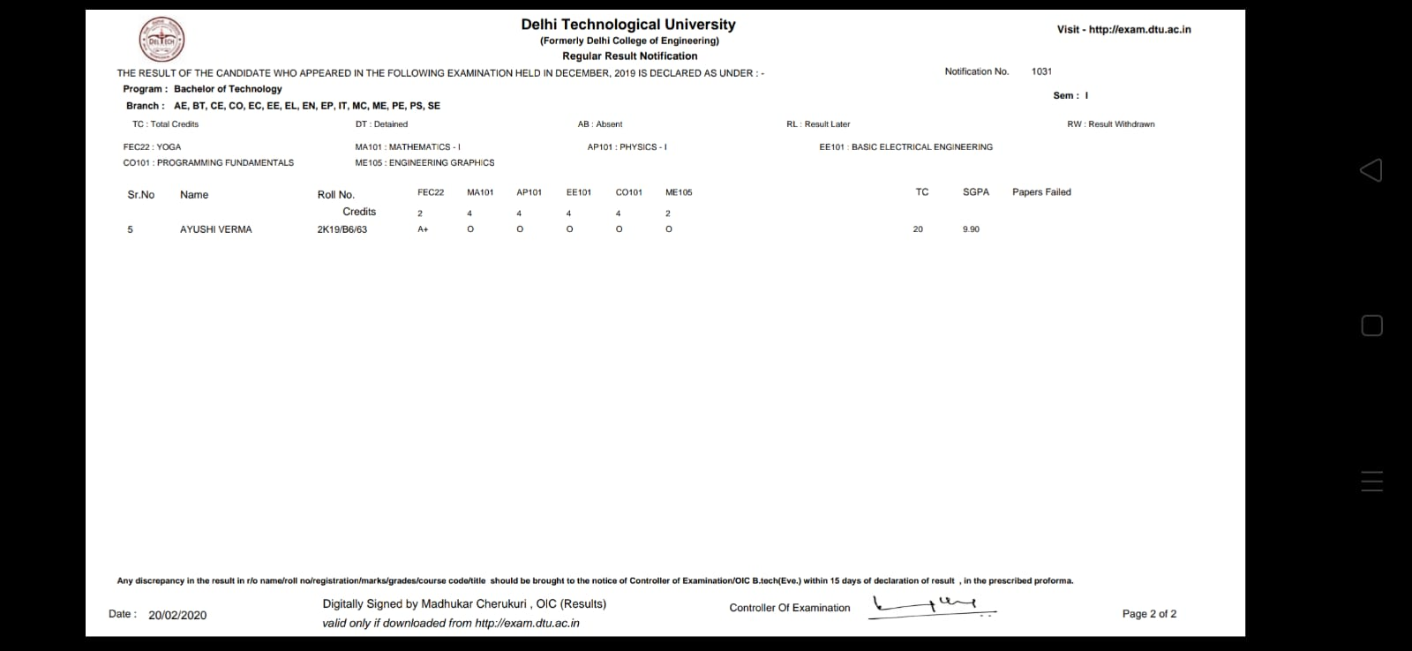

2nd semester Sr. No 2003, SGPA 9.80

